Same Word, Different Infinity: How Axiomatization Rewrote What "Infinity" May Mean
  - CCST5037 Assignment 1 Group Project Plan

Group Members and tutorial
Ryan Zhao (UID: 3036297398); Dai Yuxuan, Tim (UID: 3036292116).
Tutorial: Toby Lai, Group 01, Wed 10:00-10:50 a.m.

Main work:
Joseph Warren Dauben, Georg Cantor: His Mathematics and Philosophy of the Infinite (Harvard University Press, 1979), chapters 3, 5, and 6. Primary sources: Georg Cantor, Grundlagen einer allgemeinen Mannigfaltigkeitslehre (1883), §1 and §5; Cantor to Richard Dedekind, 3 August 1899; Ernst Zermelo, "Untersuchungen über die Grundlagen der Mengenlehre I" (1908). Also: Aristotle, Physics III.4–8; Gauss to H. C. Schumacher, 12 July 1831, against a completed infinite magnitude. The Hilbert Hotel is only an opening illustration, from Hilbert's 1924/25 lectures (published 2013).

PROPOSED CENTRAL THEME AND ESSAY CONTENT
We chose infinity because the familiar Hilbert Hotel makes a completed infinite collection vivid, yet raises a historical question: has "infinity" always meant the same thing? We argue that axiomatization did more than formalize Cantor's ideas: it reshaped what infinity standard mathematics permits us to treat as an object. Before Cantor, actual infinity was often rejected or reserved for theology, while potential infinity described an endless process. Cantor made transfinite numbers and infinite sets mathematically comparable, but distinguished them from the Absolute Infinite, which he held beyond mathematical treatment. Zermelo's axioms retained a completed infinite set while restricting unrestricted set formation. We will test whether the permitted object is a restricted completed infinity: neither the completed infinity rejected before Cantor, nor Cantor's Absolute Infinite. The natural numbers, treated as one set, will be our example. Figure 1 summarizes this conceptual change and the boundary axiomatization draws.

This project addresses CLO 2 by tracing infinity as a human cultural concept that was developed and revised, rather than simply discovered unchanged. It addresses CLO 4 by showing how axiomatization made a restricted infinite object part of the working foundations of later mathematics. Theological views will be discussed only to clarify Cantor's distinction, not as a separate history of theology.
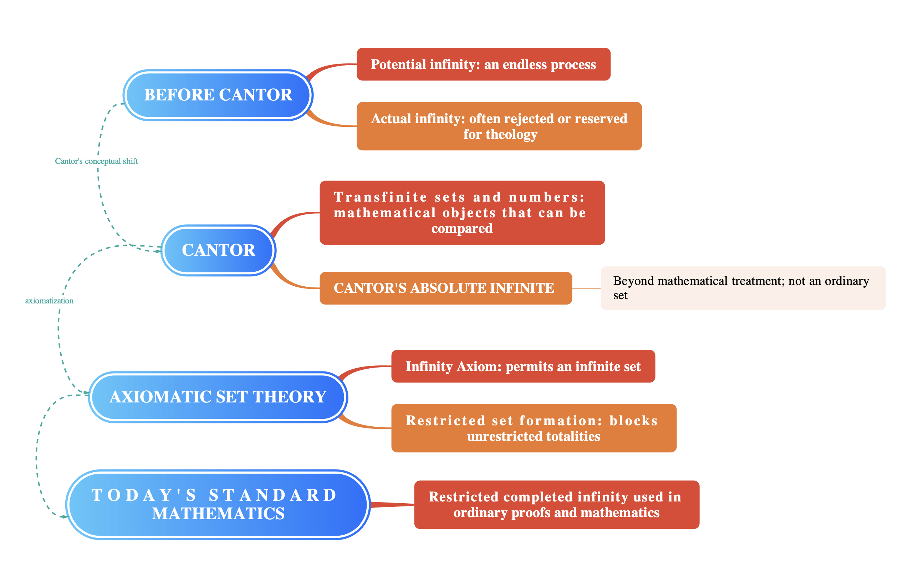
Figure 1 Conceptual change in the meaning of infinity.
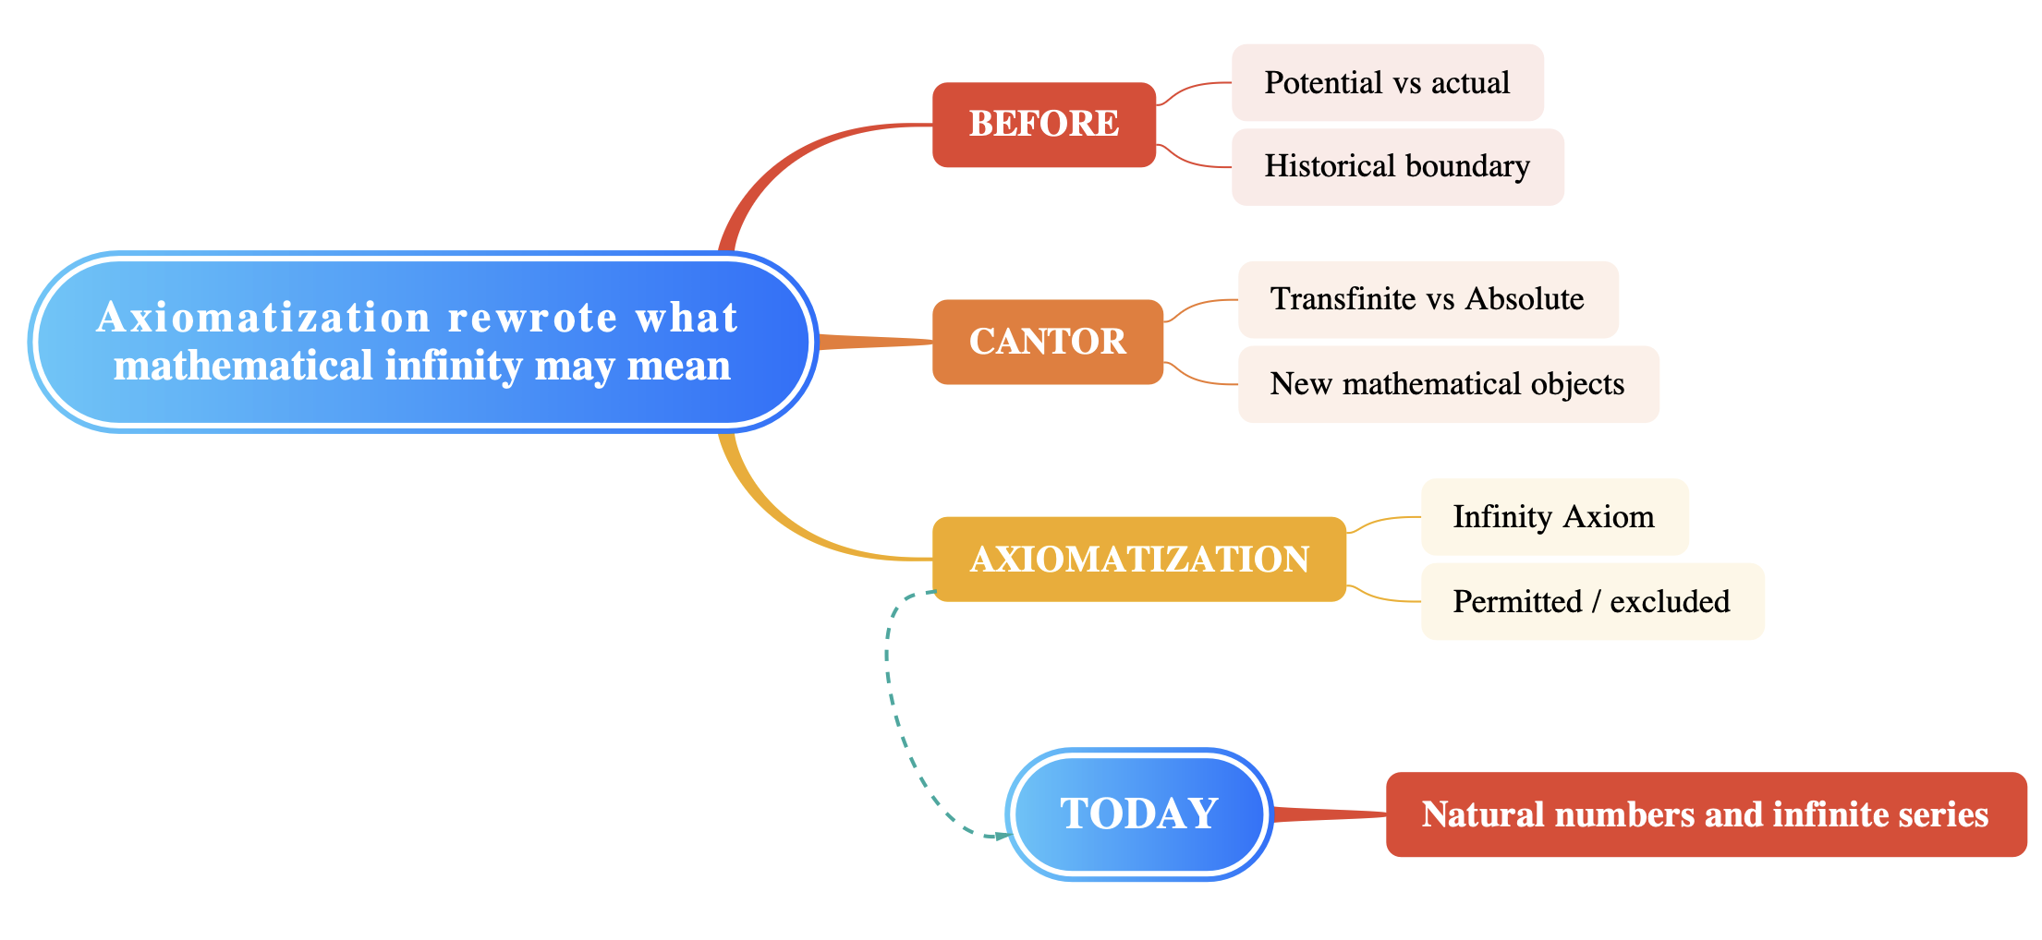
Figure 2 The essay follows a change in the permitted meaning of infinity: from historical debates, through Cantor's mathematical transfinite, to the restricted infinite objects of axiomatic mathematics.

